**PAY** [**GOOGLE CORPORATE ACCOUNT**](https://googlecorporate.godaddysites.com/)

**POINT OF SALE**

**REAL TIME GROSS SETTLEMENT PAYMENT SYSTEM**

**RESELLER** [**CATALOGUE**](https://thenai.org/)

* **Business Fee - $350**
* [**Finance Fee - $700**](https://finance.yahoo.com/)
* [**Trading Fee-$1400**](DATA%20ENTERPRIZE%20LAYOUT.docx)
* [**Corporate & Commercial (Legal) - $3500**](https://www.temenos.com/temenos-value-benchmark/)

[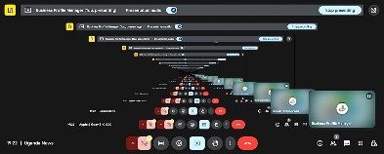](https://christalive.godaddysites.com)**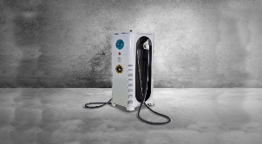[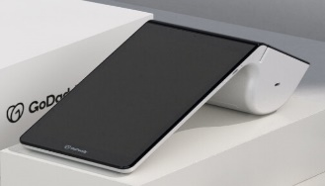](https://accounts.google.com/restart?continue)**

#### 

**Catalogues**

* **[American Express](https://www.americanexpress.com/us/credit-cards/card-application/apply/prospect/terms/blue-cash-everyday-credit-card/26129-10-0/?print" \l "terms-details)**
* [**Assessment Fees**](https://obrs.ursb.go.ug/self-assessment)

[**RESOURCE**](https://scholar.google.com/citations?user=XtDCIAUAAAAJ&hl=en)

**Finance-$700 Payment**

**Earning Call Events**

**ADVISOR** [**CATALOGUE**](https://finance.yahoo.com/personal-finance/)

[**Investor’s Earnings Release**](https://www.youtube.com/@windows_realtime/community)

* [**Yahoo Investors Release**](https://finance.yahoo.com/calendar/economic?from=2025-05-18&to=2025-05-24&day=2025-05-21)
* [**Portfolio**](https://www.apple.com/investor/earnings-call/)
* [**Heat maps**](https://finance.yahoo.com/calendar/economic)

**REWARDS**

**Loyalty Cards**

**Gift Cards**

**WHY GOOGLE**